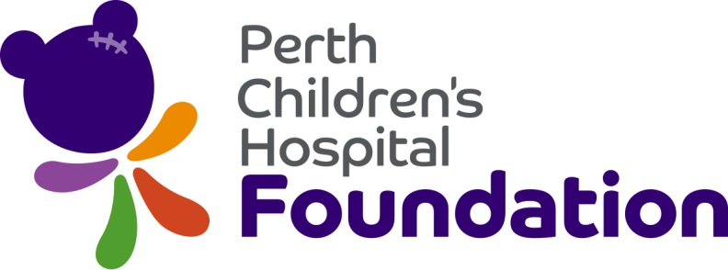

Grant Application for Funding

To apply for funding, please complete this form and submit a signed copy, along with any supporting documentation to CAHS Grants and Sponsorships via email - CAHSGrantsandSponsorships@health.wa.gov.au

Two version of the application must be provided:
- A scanned version.
- A word version of the final application so information can be easily cut and pasted as required.

Note:
- There are a number of conditions that need to be agreed to and fulfilled if funding is to be granted – these are listed above the approval section on this form.
- Perth Children’s Hospital Foundation staff and donors primarily come from non-medical backgrounds. Bear this in mind when providing your responses to the questions that follow.
- Provide as much information as possible to assist the Foundation to secure donated funds for successful applications.
- There are separate application forms for research grants and education and training grants which are available by emailing PCHFoundationGrants@health.wa.gov.au (for research) or OfficeofOperations@health.wa.gov.au (for education and training).

Project category
Please tick category that applies to the project you are seeking funds for.

Disease control or prevention via:
- Medical equipment | - Complementary service
- Non-medical equipment | - Education program/initiative

Injury or illness treatment via:
- Medical equipment | - Complementary service
- Non-medical equipment | - Education program/initiative

Applicant details
Name
Position
Telephone
E-mail
Signature
Date

Project details
Ward/Department
Project title
Amount of funding sought
- The compelling need/problem
- Describe the existing situation and why it needs to change.
- Provide as much detail as possible including the number of children/patients currently affected and the types of disease, illness, injury or conditions they face.
- Your response must clearly set out the reasons why this is not something the community should reasonably expect Government to fund as it is core to the delivery of paediatric health services in WA.

- The solution/proposed change
- Summarise what improvement is required.
- Outline how your project will ensure this improvement can be made and how it satisfies Perth Children Hospital Foundation’s primary focus which is to promote the control or prevention of disease in children as noted in the PCH Foundation Funding Guidelines (downloadable from the CAHS intranet).

- The positive impact/benefits of making the change
- List the positive differences that the above solution will have on a child, the department and/or paediatrics in general.

4. Quotable comments
- Provide a short comment from the relevant Executive Director and/or other approved spokesperson for the project that can be used in proposals to potential donors and/or media releases and articles relating to the project.
- Note that the spokesperson/s may also be required to speak to media about the project should the grant application be successful.

- Case Stories
- Provide the names and contact details of the parents/carers of at least two patients who will benefit from this initiative.
- Case stories are the most demonstrative evidence used by the Foundation to inform donors of the difference they can make. The Foundation will contact the families you suggest in order to obtain case stories and photos that will included in proposals to donors, used to publicise the work of the Foundation and assist in attracting future donors.
- You must ensure that the families you provide the details of are comfortable being approached by the Foundation for their case stories.

Name of patient:
Date of birth of patient:
Brief outline of patient’s condition:

Parent/carer name:
Parent/carer mobile number:
Parent/carer home number:

Name of patient:
Date of birth of patient:
Brief outline of patient’s condition:

Parent/carer name:
Parent/carer mobile number:
Parent/carer home number:
- Conditions
I acknowledge that it is a condition of Perth Children’s Hospital Foundation funding that I agree to:
- Provide additional contact details of patients/families who will benefit from the project so they can be approached for their story to be included in funding proposals to potential donors should those noted above not be suitable or available.
- Review drafts of written material to be used by the Foundation to promote fundraising for the project.
- Facilitate and host ward/department tours for donors.
- Attend and speak at thank you presentations with donors.
- Participate in media and other publicity activity around the project and/or provide other members of hospital/health service staff to participate in such activity.
- Acknowledge Perth Children’s Hospital Foundation and the donor through placement of an equipment tag and/or Department wall plaque and/or logo on any printed material related to the project.
- Acknowledge the Foundation as the source of the funding in media articles and publications related to the project.
- Provide a report outlining outcomes of the project as follows:
  - For equipment – three months after installation, then again 12 months after installation.
  - For complementary services - every six months for the duration of the funding.

Confirmation
I confirm that:
- I have read and completed sections 1-5 in the form;
- I have read and understood section 6 the PCH Foundation Funding Guidelines;
- The project falls within those guidelines; and
- Specifically that the project is not something that should be funded by Government nor is any equipment to be purchased to replace core equipment used in the day-to-day operation of the Department/Ward.

Approval – all applications
Divisonal Director Name

Divisonal Director Signature

Approval – all applications
Executive Director Name

Executive Director Signature

Approval – applications $250,000+
Chief Executive CAHS Name

Chief Executive CAHS Signature

Note that:
- By submitting this application the Applicant and Executive Director/Chief Executive agree to the conditions above.
- By forwarding this application onto the Perth Children’s Hospital Foundation Grants Sub-Committee for consideration, CAHS Executive also agrees to the conditions above.

