## WA First 1,000 Days Framework – November Update

### The Framework

The project team has been busy in the next phases of the project and framework development. This has included a review of relevant strategic documents, including but not limited to:

* The National Early Years Strategy – The First 1000 Days Framework will align and provide a WA-specific Framework.
* National Agreement on Closing the Gap
* The ARACY Nest – an evidence-based framework for child and youth wellbeing
* The Select Committee into Child Development Services
* A path to universal early childhood education and care – Inquiry Report

Acknowledging the number of other national and State strategies with a focus on this period, the project team is working to ensure the Framework is a conduit to existing initiatives.

### Consultation

In addition to the review of relevant strategic documents, of the team has engaged through meetings and workshops to inform framework elements, such as focus areas and priorities.

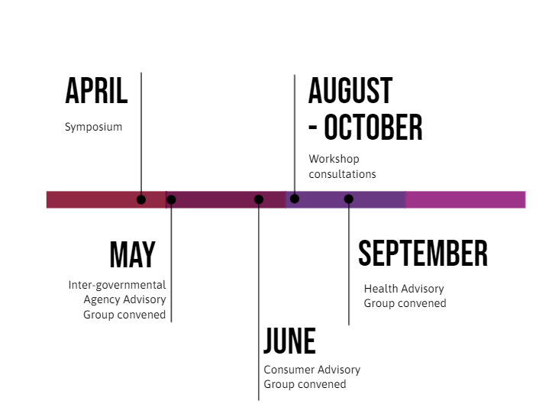

*Figure 1: Timeline of consultation activities from April – September 2024.*

Three project advisory groups have been established to provide targeted advice on the framework.

In addition to the **consumer advisory group** and **interagency group,** a **health advisory group** has been established with representatives from across WA Health. Together, these groups provide valuable feedback and expertise to inform framework development.

From August to October, the First 1,000 Days Framework team engaged with about 140 stakeholders from 30 stakeholder groups through face-to-face and online workshops, as well as ongoing consultation through the established project advisory groups.

We thank all participants for their valuable time, effort, and insights. Your contributions have been instrumental in shaping the framework to date.

Through this consultation, we have identified **four draft key focus areas** as illustrated below:

*Figure 2: Draft ecological model of the WA First 1000 Days Framework draft Focus Areas.*

**Next Steps**

The team is now identifying priorities for each focus area based on the feedback from consultation, consumers, a review of the evidence and review of other strategic initiatives.

More information, including framework development, will be provided in early 2025.

Please visit the [First 1,000 Days Framework website](https://www.cahs.health.wa.gov.au/Our-services/First-1000-Days-Framework) for a project outline. You can also contact the team at [first1000days@health.wa.gov.au](mailto:first1000days@health.wa.gov.au)